How to Create a User Account and
View Online Score Reports at https://schedule.psiexams.com

- Go to www.schedule.psiexams.com and click on “Begin Scheduling” to go to the Candidate Information Page.

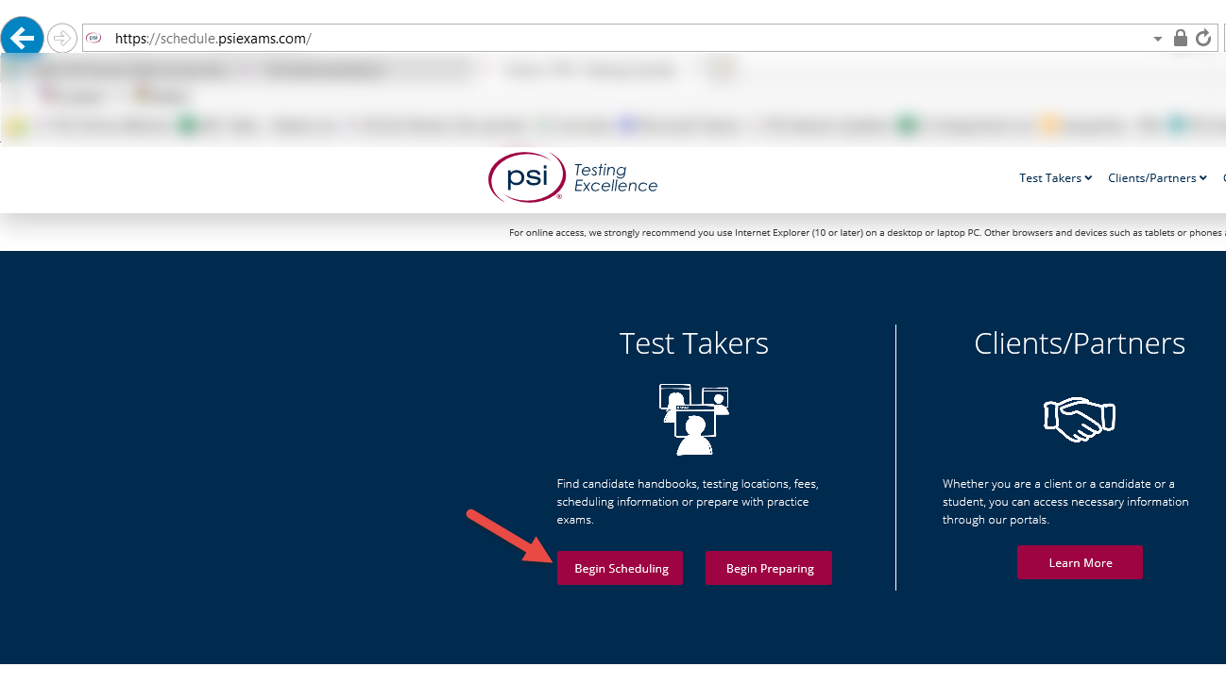

- Follow the instructions to select a Category, Program, and Examination.

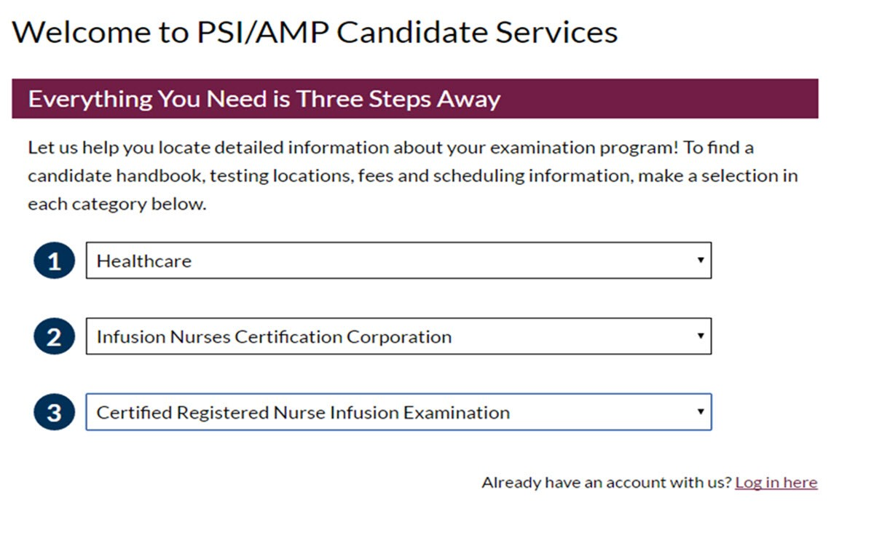

- Click on the “Candidate Home” button.

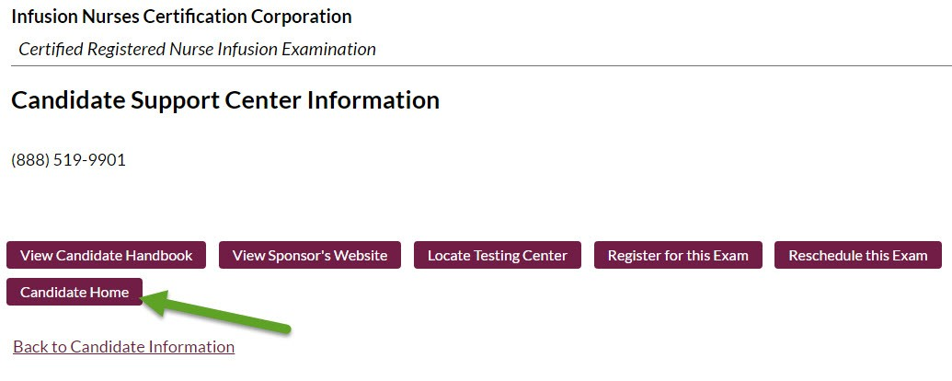

- If you do not already have a user account at www.goAMP.com, click on “New User?” to create an account.

If you already have a user account at www.goAMP.com, enter your user name and password to log in. If you need to have this information sent to you, use the “Forgot your password?” and “Forgot your user name?” links.

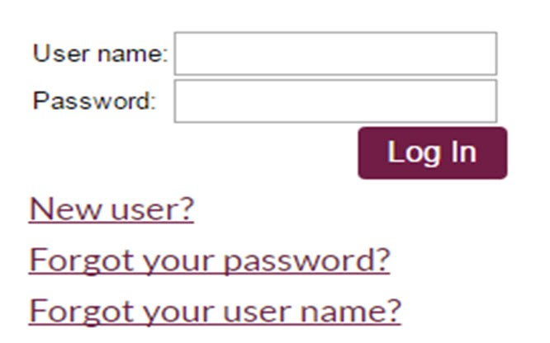

- If you are a new user, fill in the required information, including your Assigned ID number, which would have been provided to you in your Eligibility Confirmation email as your “Candidate ID”. This number should be 9 characters and may start with the letter "I". You will also be required to select and answer three security questions for verification, should you forget your username or password in the future.

- Your record may open up to the screen below, just select ‘My Home’ to proceed.

- Once you have completed registration, your account should open up to a “Previous Examinations” page as shown below:

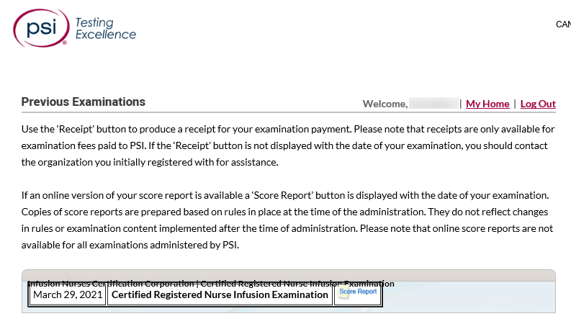

- If results are available, you will see a “Score Report” button next to the examination name and date. Click on the “Score Report” button to view your results for that examination.

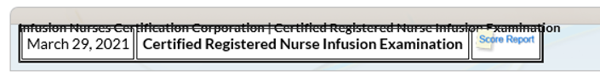

A new window should open with a PDF copy of your examination results. If the window does not open properly, you may want to make sure you have any pop-up blockers turned off and that you have the most current version of Adobe Reader installed in order to view PDF files.

